**Opening GIT Repositories in R Studios**

1. Download the GIT

<https://git-scm.com/downloads>

1. Open the R studios click
   1. File > New Project
2. Chose **Version Control**

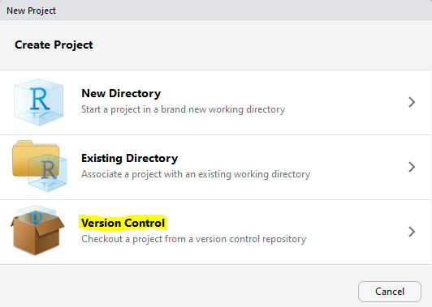

1. Choose **Git**

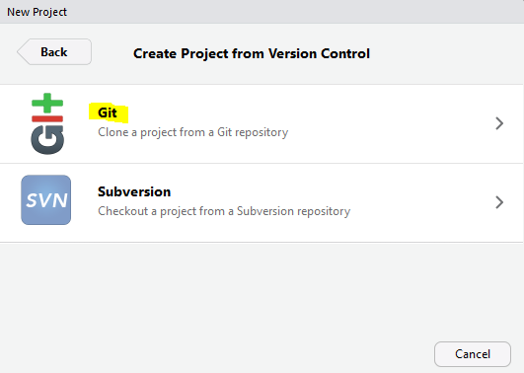

1. Fill the blank areas with using the GitHub repository director

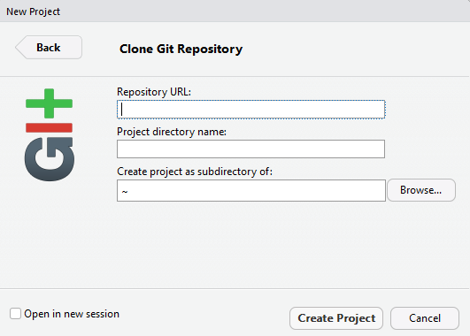

1. GitHub repository will be found in the bellowed area → (Use the yellow chosen part)

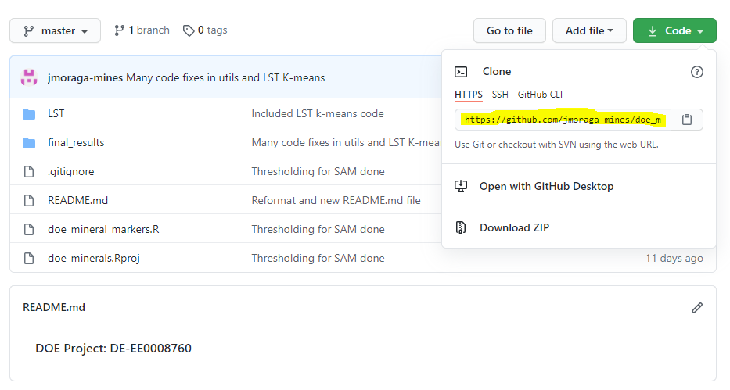

1. After paste the repository URL, click Create Project

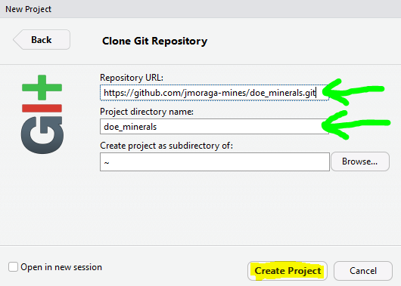

1. After clicking the Create Project button, in the green box part project will come up

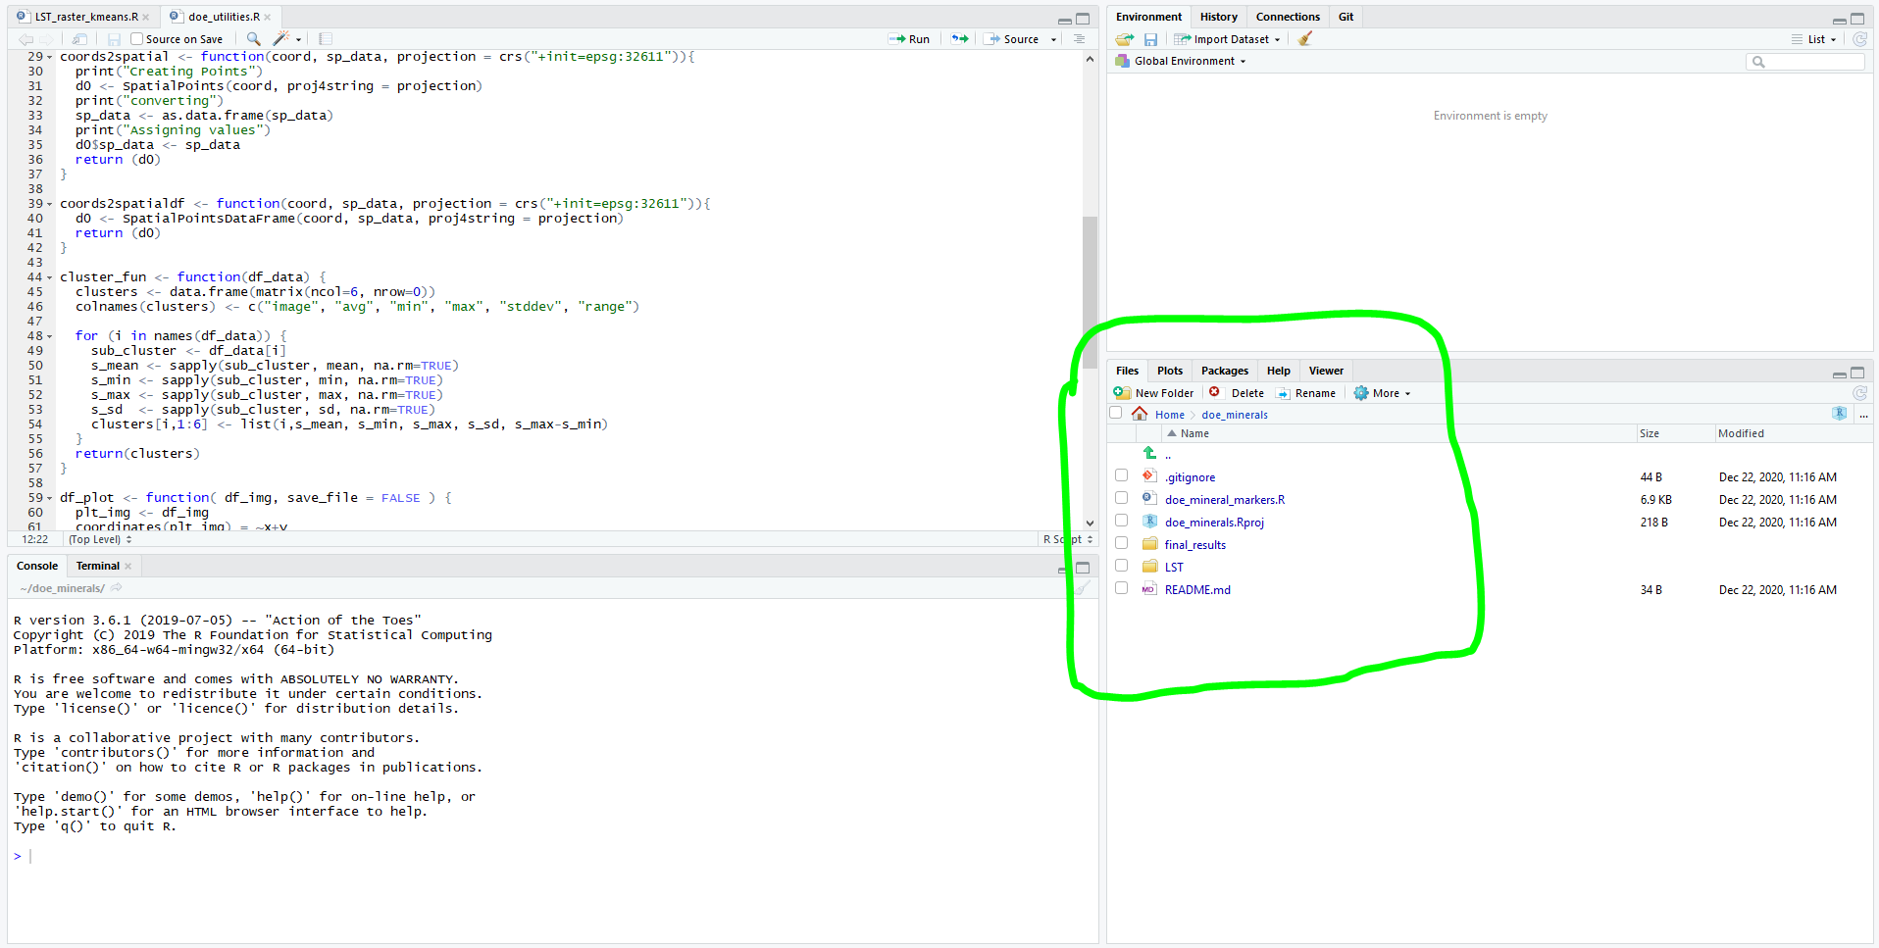

1. Using that directory start developing the CODE.